STATISTICS
Statistics is the branch of mathematics that deals with collecting, organizing, analyzing, interpreting, and presenting data.
In simple terms, statistics helps us make sense of data — it turns numbers into useful information for decision-making
TYPES OF STATISTICS
1.DESCRIPTIVE ANALYTICS
Descriptive analytics focuses on understanding historical data and providing a summary of what has happened.it involves organizing,aggregating and visualizing data to provide insights into past events,trends,and patterns.
Descriptive analytics is useful for reporting,data exploration and gaining a basic understanding of the data.
Examples:
- Mean, Median, Mode (measures of central tendency)
- Range, Variance, Standard Deviation (measures of spread)
- Graphs like histograms or pie charts
INFERENTIAL STATISTICS
It is a branch of statistics that involves drawing conclusions or making inferences about a population based on the analysis of a sample.
Examples:
- Hypothesis testing
- Confidence intervals
- Regression analysis
POPULATION
A population is the entire group of individuals, items, or data points that you want to study or draw conclusions about.
It includes every possible observation of interest.
Example:
- All students in your school
- All people living in India
- All manufactured products in a factory
✅ Population = the whole group

SAMPLE
A sample is a subset (small part) of the population, selected for study.
We collect data from the sample because it’s often impossible or expensive to study the entire population.
Example:
- 100 students selected from your school
- 1,000 citizens surveyed from across India
- 50 products tested for quality
✅ Sample = a small group taken from the population
3.PREDICTIVE ANALYTICS
Predictive analytics uses historical data and statistical models to make predictions or forecasts about future events or outcomes.it involves analyzing patterns and trends in data to estimate what is likely to happen.
It is widely used in various fields such as sales forecasting,risk assessment ,demand planning and customer behavior prediction.

Example
- A bank predicts which customers are likely to default on loans.
- A retail store forecasts next month’s sales.
- A hospital predicts which patients are at risk of disease.
- A marketing team predicts which customers are likely to buy a product.
4.PRESCRIPTIVE ANALYTICS
it goes beyond predicting future outcomes and focuses on providing recommendations or actions to optimize decisions.it combines historical data,predictive models and optimization techniques to suggest the best course of action to achieve specific goals or objectives.
It helps organizations make data-driven decisions by considering various constraints and potential outcomes.

DESCRIPTIVE STATISTICS
It can be represented in 3 main ways
1.numerical ways
2.graphical measures
3.tabular summaries
NUMERICAL WAYS
Measures of central tendency
Measures of central tendency are statistical measures that provide a representative or typical value of a dataset.they helps to summarize and describe the central or average value around which the datapoints tend to cluster.
The three commonly used measures of central tendancy are
Mean,median and mode.
MEAN
Mean=sum of all values/number of values
Eg:
Suppose the marks of 5 students are:
60, 70, 80, 90, 100
Mean=60+70+80+90+100/5
=80

MEDIAN
The median is the middle value of a dataset when the numbers are arranged in order (from smallest to largest).
It divides the data into two equal halves — half of the values are below the median and half are above it.

- Arrange the data in ascending order.
- Check if the number of observations (n) is:
  - Odd → Median is the middle value.
  - Even → Median is the average of the two middle values.
Eg:
Data: 10, 15, 20, 25, 30
Here, there are 5 values (odd number).
The middle value = 20

Data: 10, 15, 20, 25, 30, 35
Here, there are 6 values (even number).
The two middle values are 20 and 25.
Median=22.5
MODE
The mode is the value that appears most frequently in a dataset.
It shows which value occurs most often.
Data: 2, 3, 4, 4, 5, 6
Here, 4 appears twice — more than any other number.
✅ Mode = 4

Data: 1, 2, 2, 3, 3, 4
Here, both 2 and 3 appear twice.
✅ Mode = 2 and 3

Data: 5, 6, 7, 8
All values appear only once.
✅ No mode

MEASURES OF SPREAD /DISPERSION
They quantify the spread or variability of the data points around the central tendency,indicating how spread out the data values are.these includes
Standard deviation
Variance
Range
Percentile
IQR

RANGE
The difference between the biggest and smallest number.
Suppose the marks of 5 students are:
45, 60, 75, 80, 90
Range=90-45=90

So, the range helps you understand the spread or variability in data —
but remember, it only considers the two extreme values, not all data points.
STANDARD DEVIATION
The standard deviation is a measure of how much the data values deviate (spread out) from the mean (average) of the dataset.
It tells you how consistent or variable your data is.
• A small standard deviation → values are close to the mean (less spread).
• A large standard deviation → values are spread out (more variation).
Eg:
Consider the numbers 10,20,30
Here mean=20
Finding the deviation from mean
10-20=-10
20-20=0
30-20=10

Taking the squares of each deviation
100,0,100
Taking its average
100+100/3=66.67

Taking its route
Root(66.7)=8.16
Sd=8.16
• The data values deviate from the mean by about 8.16 units on average.
• If all numbers were close to 20, SD would be small.
• If numbers were more spread (like 5, 50, 100), SD would be large.

VARIANCE
Variance is the average of the squared differences between each data point and the mean
Here 66.67 is the standard deviation
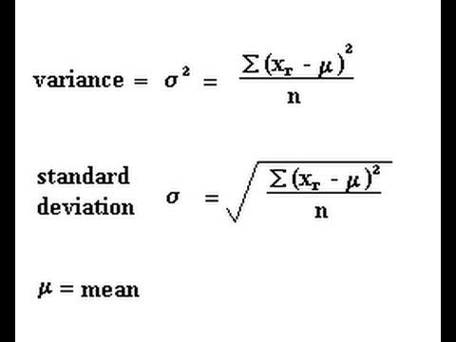
IQR(INTER QUARTILE RANGE)
The Interquartile Range (IQR) is a measure of spread or variability that shows the range within which the middle 50% of the data lies.
It helps you understand how tightly packed or spread out the central values are.
Boxplots are based on these calculations
The IQR is the difference between the third quartile (Q3) and the first quartile (Q1).
IQR=Q3-Q1
When data is arranged in ascending order:
- Q1 (First Quartile) → 25% of data lies below this value
- Q2 (Median) → 50% of data lies below this value
- Q3 (Third Quartile) → 75% of data lies below this value
So, IQR measures the spread of the middle 50% of data (between Q1 and Q3).
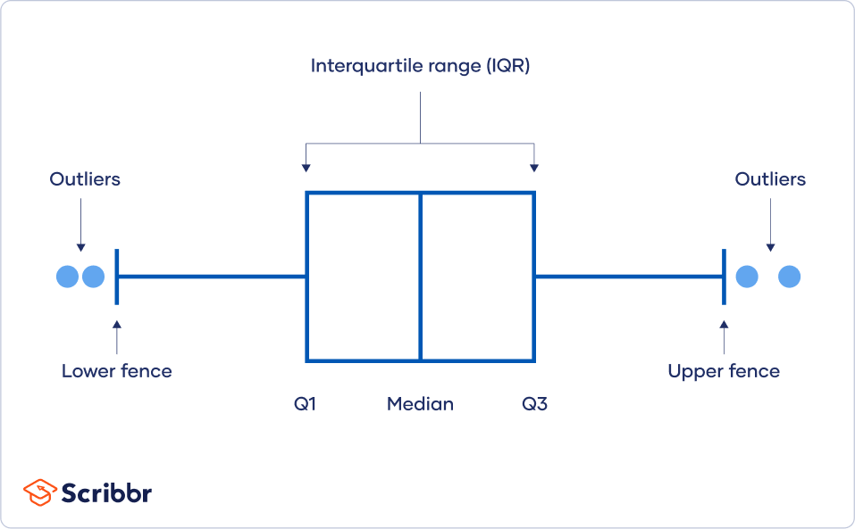

Data:
5, 7, 8, 12, 13, 14, 18, 21, 23
Step 1: Find Q1, Q2 (Median), Q3
- Median (Q2) = 13
- Q1 = median of lower half (5, 7, 8, 12) = (7 + 8)/2 = 7.5
- Q3 = median of upper half (14, 18, 21, 23) = (18 + 21)/2 = 19.5
Step 2
IQR=Q3−Q1=19.5−7.5=12
OUTLIERS
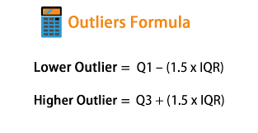
MEASURES OF SYMMETRY/SHAPES
Symmetry
Symmetry means balance or similarity in shape, size, and arrangement of parts on opposite sides of a dividing line, plane, or around a center point.
The commonly used measures of symmetry are
Skewness and kurtosis
SKEWNESS
Skewness is a measure of asymmetry (lack of symmetry) in a data distribution.
In simple terms, it tells us whether the data is spread more on one side of the mean than the other.
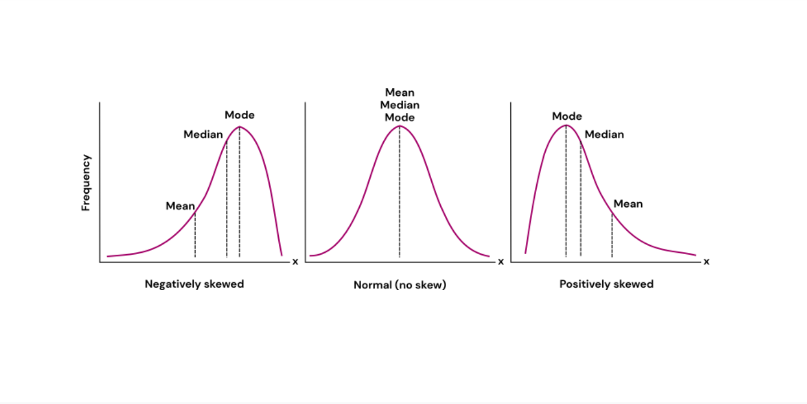
Negatively skewed-left skewed
Positively skewed-right skewed
If skewness is bw -0.5 and 0.5 ,the data is fairly symmetrical
If skewness is between -1 and -0.5 or between 0.5 and 1,the data is moderately skewd

If skewness is less than -1 or greater than 1,then the data is highly skewed
What should we do when there is skewness in your data:
Skewness becomes a problem mainly when you use statistical models that assume normality, such as:
- Linear regression
- t-tests
- ANOVA
- PCA (Principal Component Analysis)
These models assume that:
- Residuals (errors) or data are normally distributed
- Variance is constant
If the data is heavily skewed, these assumptions are violated, which can lead to:
- Biased estimates
- Invalid hypothesis test results
- Poor predictive performance
If skewness causes problems, you can reduce it using:
- Log transformation → np.log(x) (for right-skewed data)
- Square root or cube root transformation
- Box–Cox or Yeo–Johnson transformations
- Use robust algorithms that don’t assume normality (like tree-based models: Random Forest, XGBoost).

KURTOSIS
Kurtosis measures the degree of peakedness or flatness of a distribution.it indicates whether distribution has heavy tails or not.a positive kurtosis value indicates heavier tails than a normal distribution (leptokurtic),while a negative kurtosis value indicates lighter tails(platykurtic).a kurtosis value of 3 indicates a normal distribution.
